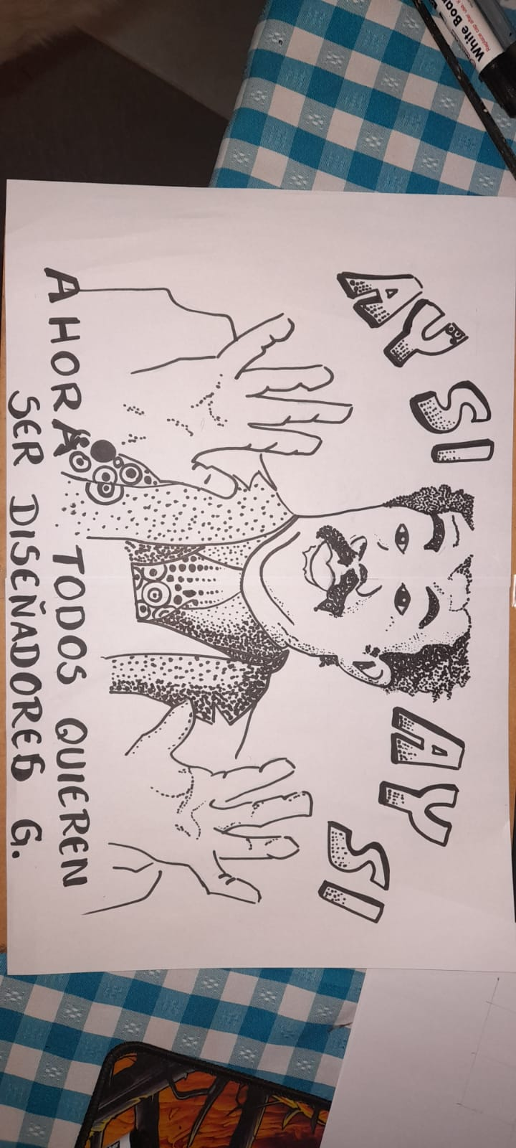

Est: TORRES VARGAS CARLOS MARCELO